***PAAREES PERFUMES***

***DAVIDOFF***

***FOR WOMEN***

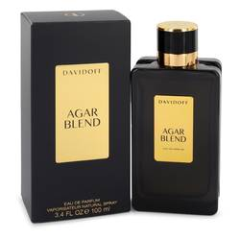

# *Davidoff Agar Blend*

***Description:***

Davidoff Agar Blend by Davidoff Perfume. Davidoff Agar Blend is an edgy, unique fragrance for women released in 2015. The perfume comes in a sleek black bottle with gold highlights, emphasizing the sophistication of the scent. The top notes are a spicy blend of black pepper, cinnamon and cloves that give this scent a memorable, energizing opening. Agarwood is a prized perfume ingredient featured in the middle notes, and it brings a richly musky tone. It is paired with guaiac wood, another woody scent that brings a smoky note. The base is creamy, resinous amber and benzoin, which adds a vanilla tinge. It has a long-lasting sillage that ensures the scent will follow you all day.  
  
Davidoff is a Swiss accessories brand with the parent company Coty. It has manufactured leather goods and watches, but the brand began producing perfume and cologne in 1984. Since then, the company has released 84 distinctive scents. It has mastered aqueous scents, spicy scents and more.